MC900239561[1]

**March Coffee Chat**

**Topic: Behavioral Difficulties**

**Why is my child doing that?**

**The ABCs for understanding and changing behavior.**

Based on the work of Dr. Joe Ryan and other professionals in the field, the group will discuss causes of problem behavior and interventions to try.  Participants will have an opportunity to connect with other parents and professionals in the Brockport Community.

Join us for this presentation by Betsy Fitzpatrick and Kelly Keenan, Instructional Coaches.

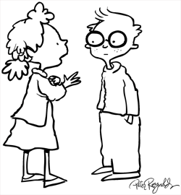

**Join us!**

**Time:**

6:30-7:30 PM

**Date:** March 13th

**Location:** BCSD Training Center

(former bus garage)

MC900239561[1]